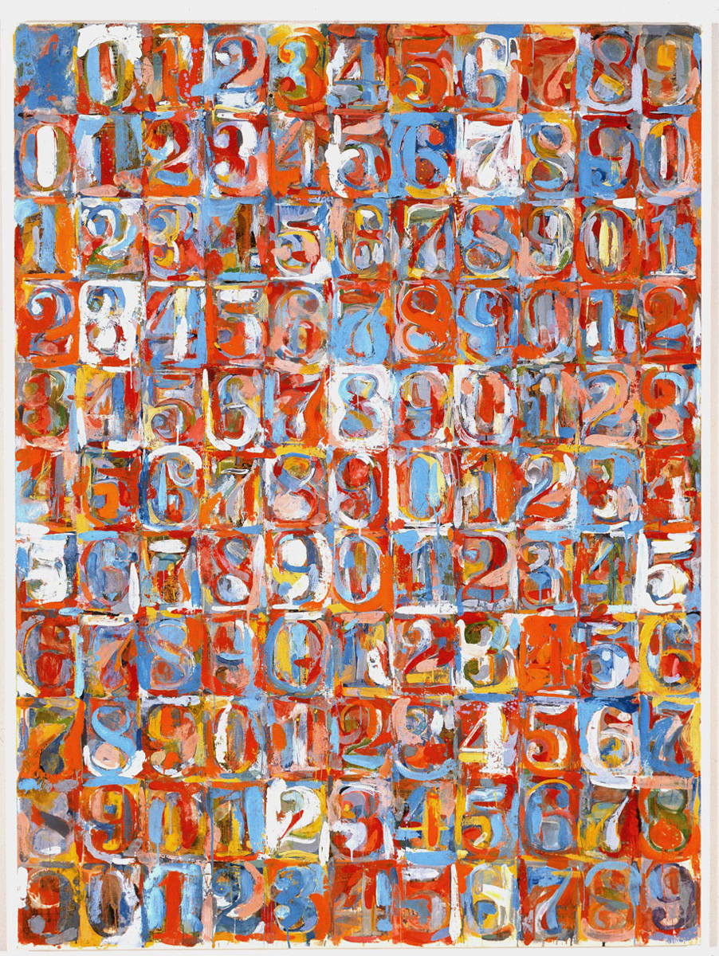
Jasper Johns 1930-present
Numbers in Color 1958-59
Contemporary Art
American Artist

Find the Definitions -
Contemporary Art
Pattern
Regular Pattern
Irregular Pattern

